Large American Tire Testing Proving Ground signes major contract for Rajd Proving Ground Management and Safety Solution.

  - press release, piteå, JANUARY 2019
Rajd Systech AB develops, markets and delivers Safety Solutions for Proving Ground Management to the global automotive testing industry. Delivering both standard solutions as well as customized solutions specifically tailored for individual Proving Grounds. The Rajd Proving Ground Management and Safety Solution (Rajd PGM) incorporates Safety with a Business Tool ensuring optimal flow embracing all aspects within the business chain www.rajdsystech.se.

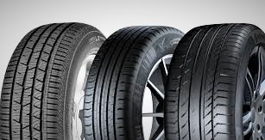

Rajd Systech AB is proud to announce that one of the worlds largest Tire Manufacturer has signed a major contract with us for our Rajd Proving Ground Management Solution. The solution will be implemented at their testing facility in US. The client invests heavily in Safety on all their facilities worldwide and the Rajd Team is honoured to be selected as a supplier.

